EXP NO 2: Create A Simple Cloud Software Application For Flight Reservation System Using Any Cloud Service Provider To Demonstrate Saas.

AIM:
To create a simple cloud software application for flight reservation system using
any cloud service provider to demonstrate saas.

PROCEDURE:
step1: Go to zoho.com.
step 2: Log into the zoho.com.
step 3: Select one application step.
step4: Enter application name as flight reservation system.
step 5: Created new application flight reservation system.
step 6: Select one form.
step 7: The software has been created.

Output:
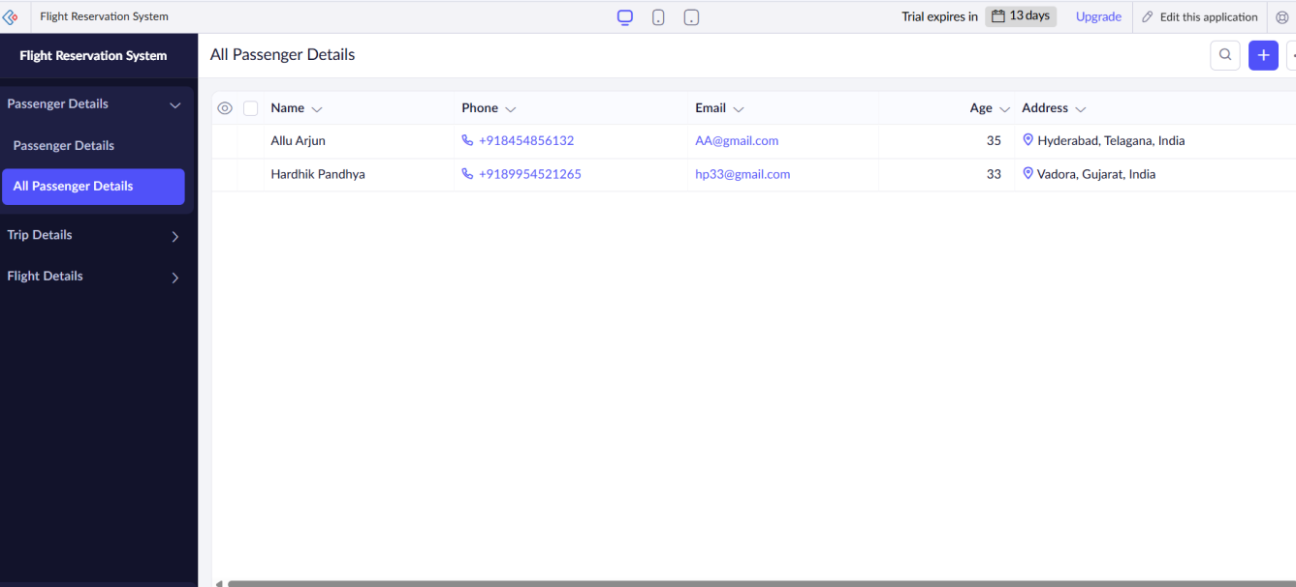

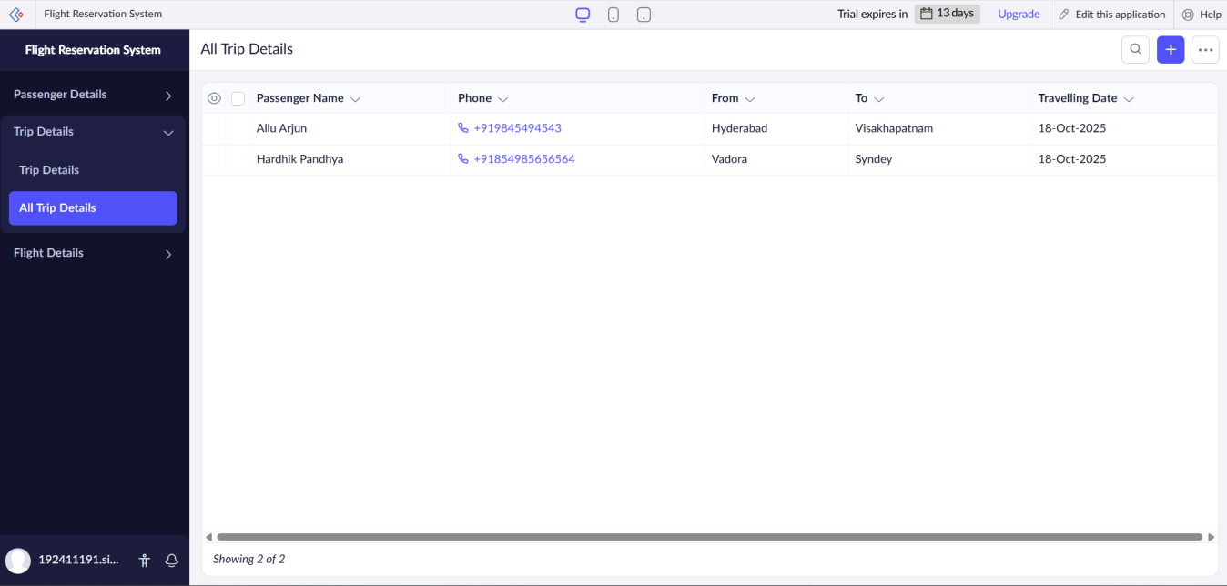

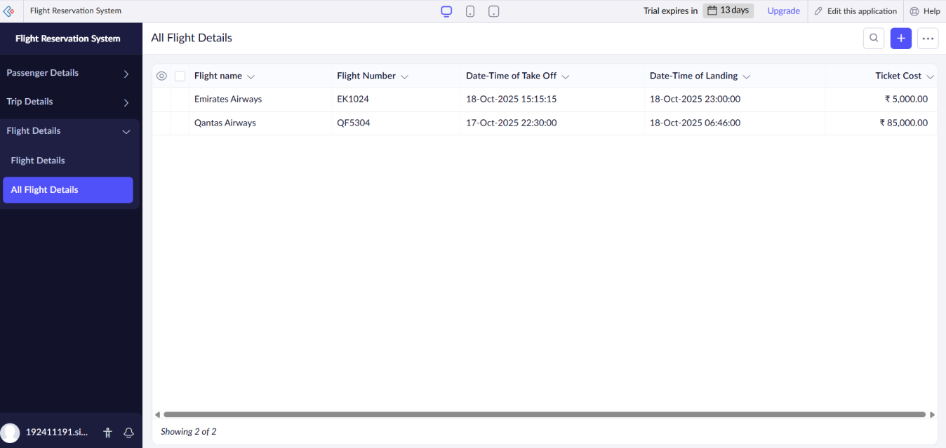

Results:
A simple cloud software application for flight reservation system using any cloud service provider to demonstrate saas has been successfully implemented.

